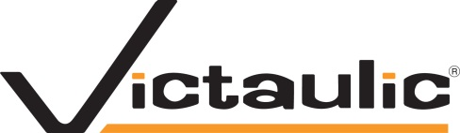 | Victaulic Procedure
 | ISSUED BY: HR Department
 | REVISED:
 | ISSUED DATE: December 2013
Accessibility for Ontarians with Disabilities Act-  Integrated Accessibility Standards Policy | APPROVED BY:  Jared Breidinger, VP & General Manager

Victaulic is committed to meeting the accessibility needs of persons with disabilities. We are committed to doing so through the development of policies and practices which are regulated under the Accessibility for Ontarians with Disabilities Act.

PURPOSE
The purpose of this policy is to communicate Victaulic’s commitment to ensuring that, where possible, goods and services will be provided to persons with disabilities in a manner which is as effective as possible and maintains the dignity of those persons.

GENERAL

Victaulic has met all requirements in regards to the Customer Service Accessibility Standard, as of December 2012. Over the next 12 years, we will work to comply with the requirements under the Integrated Accessibility Standards which are applicable to our business.

Information and Communication Standard
Victaulic will ensure that we review all sources of information we provide and, where possible, will provide this material in formats that are accessible to those with disabilities. This includes company material, information and our website.

Employment Standards
We will review our recruitment practices, including job postings, hiring practices, and job requirements, to ensure that, where possible, we are meeting the needs of those with disabilities. We will review our internal accommodation processes.

Design of Public Spaces Standard
Should Victaulic newly construct or redesign any of our public spaces within Ontario, we will work to ensure that, where possible, the facilities are accessible to those with disabilities.

The Human Resources department is committed to staying up to date on the requirements of the AODA and working with applicable parties to review, and implement requirements to meet the standards where possible.

